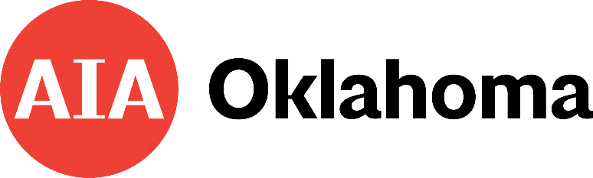
2025 AIA Oklahoma Honor Awards
Nomination Form

Indicate the Category of Nomination:
- AIA Oklahoma Award for Outstanding Educational Contributions
- AIA Oklahoma Award for Community Service
- AIA Oklahoma Award for Young Professional Achievement
- AIA Oklahoma Award for Distinguished Service
- AIA Oklahoma Award for Lifetime Achievement

Nominee’s Full Name:
Nominee’s Firm/Organization Name: Mailing Address:

Telephone:

E-mail:

If Nominee is a Firm or Organization, provide the Contact information:

Name:

Phone: E-mail:

Nominating Sponsor is:  an AIA Member  an AIA Chapter Name of person preparing nomination packet:
(if different from nominating sponsor; please print)

Phone: E-mail: Is nominee aware of this submittal for an AIA Oklahoma Honor Award?  Yes  No
Submit this form, along with the power point required to aiaoklahoma@cox.net
Deadline for Submission is Monday, March 3, 2025

