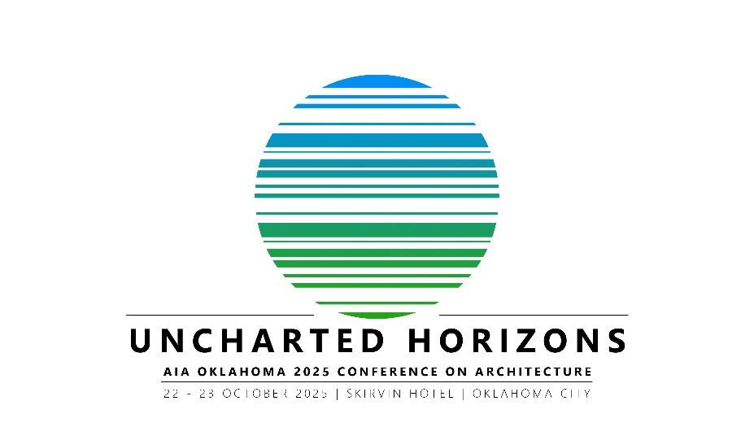
CALL FOR SPEAKERS

The AIA Oklahoma Conference on Architecture Planning Committee is looking for speakers for the 2025 AIA Oklahoma Conference on Architecture.
Conference Details: This year’s conference will take place in Oklahoma City at the Skirvin Hotel on Wednesday, October 22nd and Thursday, October 23rd.
Conference Theme: This year’s theme is UNCHARTED HORIZONS. Uncharted Horizons invites architects, designers, and industry leaders to explore the future of the built environment beyond conventional boundaries. This year’s theme challenges us to embrace innovation, push creative limits, and redefine possibilities in design, technology, and sustainability.
Compensation: Complimentary registration will be offered to all speakers. Select speakers from outside of Oklahoma will also be offered a stipend to assist with expenses, including airfare, hotel, meals, etc.

How to Submit Proposals
Submission Deadline: All proposals must be completed and submitted no later than Friday, May 2, 2025. The Committee will give preference to health, safety, and welfare (HSW) programming but are specifically looking for unique programming that is of interest to the Architects in the State of Oklahoma.

Program Details: Each program is 50 minutes, and all presenters must provide AIA Oklahoma with a digital copy of their presentation as well as workshop handouts by October 17, 2025.

If you have any questions, please contact AIA Oklahoma at 405-948-7174 or 918-583-0013 or aiaoklahoma@outlook.com.

PRESENTER CONTACT INFORMATION

FULL NAME: Click or tap here to enter text.

COMPANY: Click or tap here to enter text.

EMAIL: Click or tap here to enter text.

OFFICE PHONE: Click or tap here to enter text.

CELL PHONE: Click or tap here to enter text.

MEMBER STATUS: Choose an item.
COURSE TITLE

PROPOSED PRESENTATION TITLE: Click or tap here to enter text.

PRESENTATION DATE & TIME PREFERENCE
(Check all that apply)

☐Wednesday Morning ☐Wednesday Afternoon ☐ No Preference
☐Thursday Morning ☐Thursday Afternoon

full COURSE DESCRIPTION
(300 word max)
Click or tap here to enter text.
SHORT COURSE DESCRITION
(Provide a short description of 50 words or less to be used in the conference brochure should your program be selected).
Click or tap here to enter text.
F. LEARNING OBJECTIVES
Four learning objectives are required by AIA CES. A learning objective is an explanation of the learning outcomes for the course. The learning objectives should clearly express what the adult learner will be able to do after taking the course. For the course to be eligible for Health, Safety and Welfare (HSW) credit, three of the following four objectives must reflect HSW topic areas.

HSW definition: Licensed architects and affiliated design professionals have, in their professional practice, a positive duty to protect the public’s health, safety, and welfare. Learning programs must address knowledge intended to protect the health, safety, and welfare of the occupants of the built environment, as defined below:

• Health Those aspects of professional practice that improve the physical, emotional, and social well-being of occupants, users, and any others affected by buildings and sites.

• Safety Those aspects of professional practice that protect occupants, users, and any others affected by buildings or sites from harm.

• Welfare Those aspects of professional practice that enable equitable access, elevate the human experience, encourage social interaction, and benefit the environment

Is this program HSW? ☐ Yes ☐ No

Please briefly explain why this program fits into the HSW category:
Click or tap here to enter text.

Please provide 4 learning objectives for your presentation:
- Click or tap here to enter text.
- Click or tap here to enter text.
- Click or tap here to enter text.
- Click or tap here to enter text.

Additional Presenters / Panelists:

FULL NAME: Click or tap here to enter text.

COMPANY: Click or tap here to enter text.

EMAIL: Click or tap here to enter text.

OFFICE PHONE: Click or tap here to enter text.

CELL PHONE: Click or tap here to enter text.

MEMBER STATUS: Choose an item.

FULL NAME: Click or tap here to enter text.

COMPANY: Click or tap here to enter text.

EMAIL: Click or tap here to enter text.

OFFICE PHONE: Click or tap here to enter text.

CELL PHONE: Click or tap here to enter text.

MEMBER STATUS: Choose an item.

FULL NAME: Click or tap here to enter text.

COMPANY: Click or tap here to enter text.

EMAIL: Click or tap here to enter text.

OFFICE PHONE: Click or tap here to enter text.

CELL PHONE: Click or tap here to enter text.

MEMBER STATUS: Choose an item.

Biography
Please provide a brief bio (and that of your additional panelists) in paragraph form. This will be used in the conference brochure.
(125 word max)
Click or tap here to enter text.

HEAD SHOT
Please attach a head shot with the application to be used in the conference brochure should your program be selected.
Submit
Please title this application with your name (i.e. john doe.docx) and submit a copy to melissa@aiacoc.org and to lindsey@aiarchitects.com by Friday, May 2, 2025.

